Unit 4 – Lesson 9. What’s new in Android Studio 3.0?
Aim:
- How do we upgrade to Android Studio 3.0 and what new features are offered?

Objectives: After the lesson, students will be able to:
- Upgrade to Android Studio 3.0 and obtain understanding of Android Studio 3.0.

CLASS PROCEDURE:

Do Now:
Open Android Studio. On the lower right corner, find a link for “Update”. Click on the link and you shall see this panel pops up. Click on “Update and Restart” to upgrade your Android Studio to 3.0.
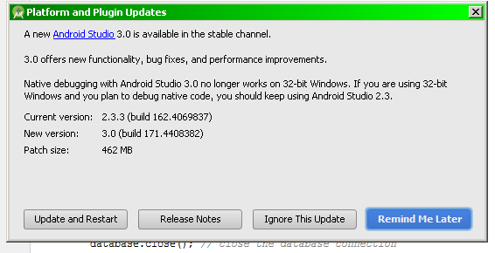

Class Presentation / Discussion:
- What are the new features in Android 3.0?
https://android-developers.googleblog.com/2017/05/android-studio-3-0-canary1.html

- What impact would this upgrade have on our SQLite project?
https://medium.com/@ajaysaini.official/building-database-with-room-persistence-library-ecf7d0b8f3e9

Pair – sharing / Practice:
Continue working on the SQLite project. Due: November 18th.

